**Future Prediction of Items**

Day 4:

In the provided zip folder (name: tensorflow.rar file uploaded in Github) I have developed an app in Android studio. This entire app(tensorflow) takes the cid(customer id) as input and gives the highest purchased item quantity and the name of product is displayed as follows:

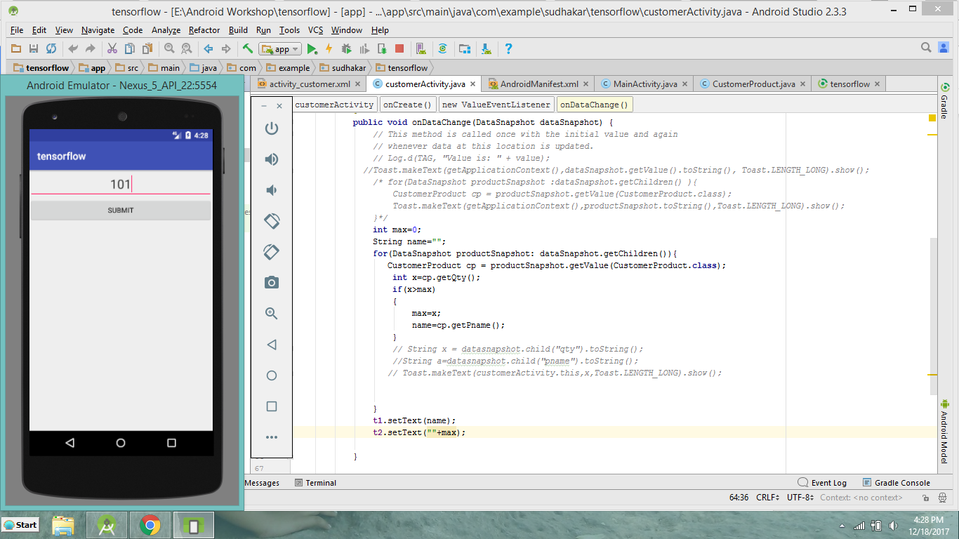

First on enetering the customer id (cid) and submit we have as:

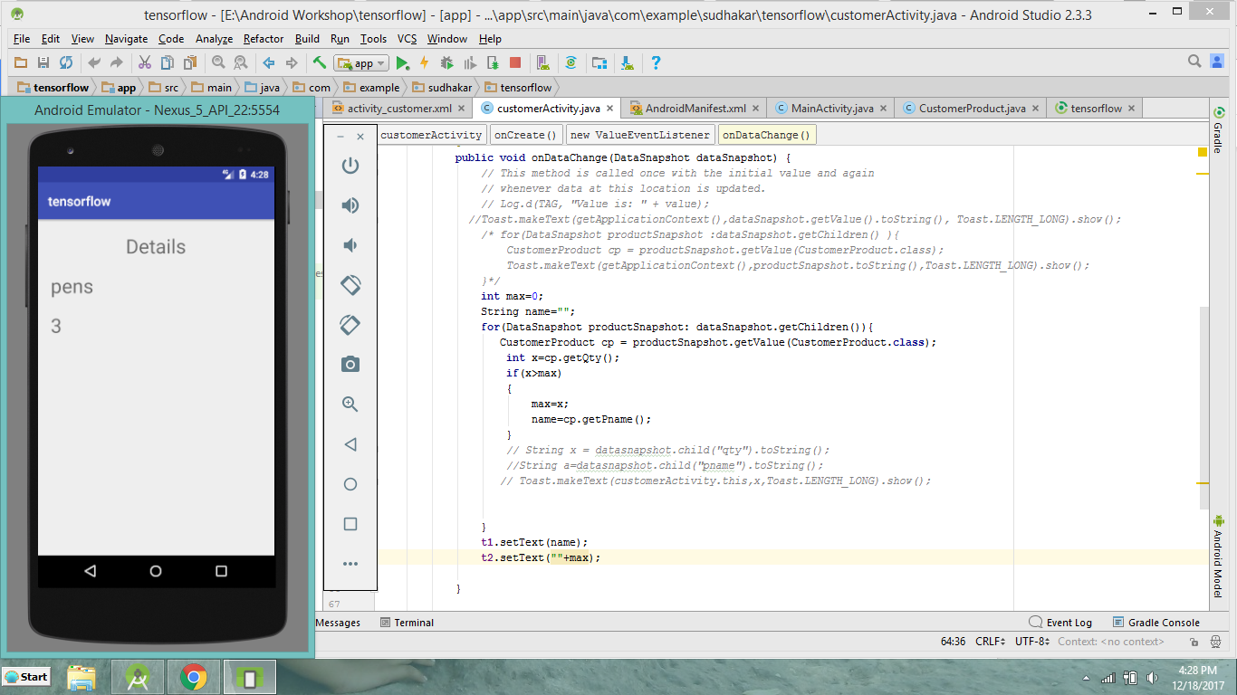

So the highest purchased product by customer id(101) is pens with quantity 3.

Similarly, for 102 it is as:

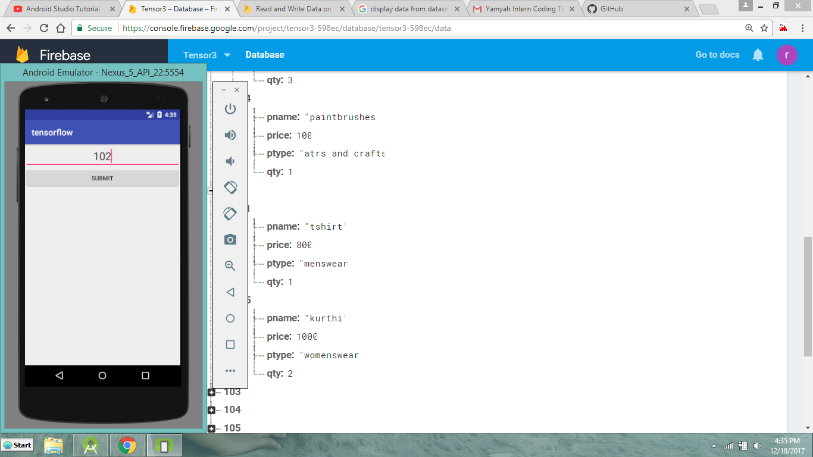

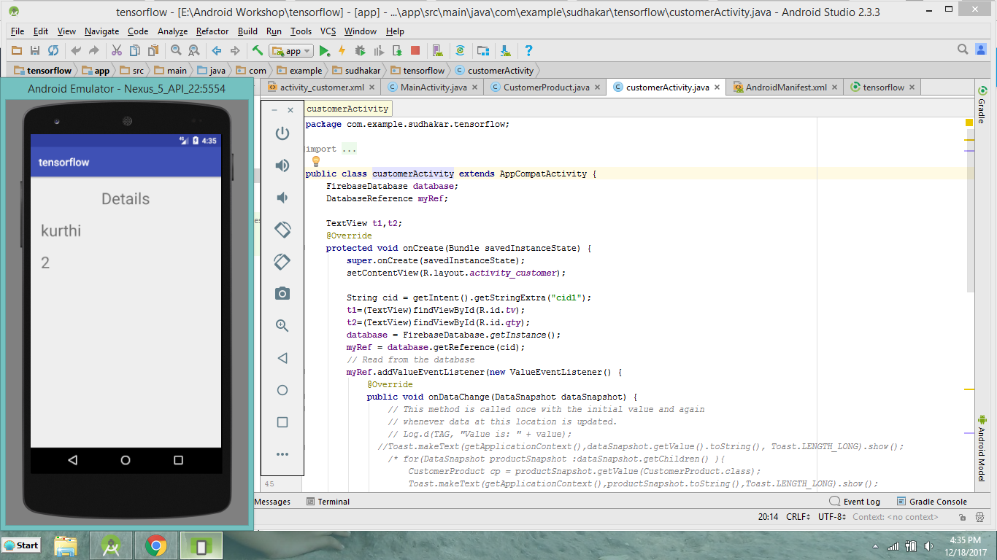

So the highest purchased product by customer id(102) is kurthi with quantity 2.

Similarly we can retrieve all other customers most frequently purchased items from the app(tensorflow) for the data stored in fire base data base(https://console.firebase.google.com/project/tensor3-598ec/database/tensor3-598ec/data/).